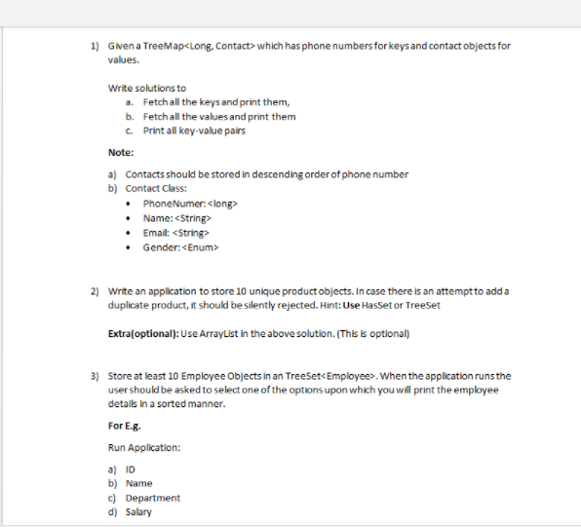

1.

**package** JavaCollections;

**import** java.util.*;

**public** **class** TreeMapOperations {

**public** **static** **void** main(String[] args)

{

TreeMap<Integer,String> details = **new** TreeMap<>();

details.put(1004783791, "abc");

details.put(1004783792, "abc");

details.put(1004783793, "abc");

details.put(1004783794, "abc");

details.put(1004783795, "abc");

System.***out***.println("treemap elements:"+details);

Set<Integer> keys = details.keySet();

System.***out***.println("keys");

**for**(Integer key: keys){

System.***out***.println(key);

}

Set<Integer> values = details.keySet();

System.***out***.println("values");

**for**(Integer value : values) {

System.***out***.println(value);

}

}

}

2.

**package** JavaCollections;

**import** java.util.*;

**public** **class** HashsetOperation {

**public** **static** **void** main(String[] args)

{

HashSet<String> set = **new** HashSet<>();

set.add("abc");

set.add("def");

set.add("ghi");

set.add("ijk");

set.add("mno");

set.add("pqr");

set.add("stu");

set.add("vwx");

set.add("yza");

set.add("bcd");

System.***out***.println("before adding duplicate element:"+set);

set.add("abc");

System.***out***.println("after adding duplicate element:"+set);

}

}

3.

package JavaCollections;

import java.io.*;

import java.util.Comparator;

import java.util.TreeSet;

public class Employees {

public static void main(String[] args)

{

System.out.println("Sorting on the basis of name in Ascending order");

TreeSet<Employee> gfg = new TreeSet<>(new FirstComparator());

gfg.add(new Employee(1, "ram", 24000,"abc"));

gfg.add(new Employee(2, "krishna", 23000,"def"));

gfg.add(new Employee(3, "sita", 26000,"ghf"));

gfg.add(new Employee(4, "lakshman", 25000,"sdg"));

for (Employee employee : gfg)

{

System.out.println(employee);

}

System.out.println( "Sorting on the basis of name in Descending order");

TreeSet<Employee> gfg2 = new TreeSet<>(new SecondComparator());

gfg2.add(new Employee(1, "ram", 24000,"adf"));

gfg2.add(new Employee(2, "krishna", 23000,"sag"));

gfg2.add(new Employee(3, "sita", 26000,"sdhh"));

gfg2.add(new Employee(4, "lakshman", 25000,"aggd"));

for (Employee employee : gfg2)

{

System.out.println(employee);

}

System.out.println("Sorting on the basis of age in ascending order");

TreeSet<Employee> gfg3 = new TreeSet<>(new ThirdComparator());

gfg3.add(new Employee(1, "ram", 24000,"xsh"));

gfg3.add(new Employee(2, "krishna", 23000,"sjh"));

gfg3.add(new Employee(3, "sita", 26000,"sbh"));

gfg3.add(new Employee(4, "lakshman", 25000,"shbc"));

for (Employee employee : gfg3)

{

System.out.println(employee);

}

}

}

class FirstComparator implements Comparator<Employee>

{

@Override

public int compare(Employee e1, Employee e2)

{

return (e1.name).compareTo(e2.name);

}

}

class SecondComparator implements Comparator<Employee>

{

@Override

public int compare(Employee e1, Employee e2)

{

return -(e1.name).compareTo(e2.name);

}

}

class ThirdComparator implements Comparator<Employee>

{

@Override

public int compare(Employee e1, Employee e2)

{

if (e1.salary > e2.salary) {

return -1;

}

else if (e1.salary < e2.salary) {

return 1;

}

else {

return (e1.salary).compareTo(e2.salary);

}

}

}

class Employee {

public int id;

public String name;

public Integer salary;

public String department;

Employee() {}

public Employee(int id, String name, Integer salary, String department) {

super();

this.id = id;

this.name = name;

this.salary = salary;

this.department = department;

}

@Override

public String toString()

{

return " " + this.id + " " + this.name + " "

+ this.salary+" "+this.department;

}

}